Neeraj Appari S073

Aim: Design a basic calculator app on Android(+,-,*,/)

Xml Code

<?xml version="1.0" encoding="utf-8"?>

<RelativeLayout xmlns:android="http://schemas.android.com/apk/res/android"

xmlns:app="http://schemas.android.com/apk/res-auto"

xmlns:tools="http://schemas.android.com/tools"

android:layout_width="match_parent"

android:layout_height="match_parent"

android:background="#51025E"

android:backgroundTint="#510260"

tools:context=".MainActivity">

<Button

android:id="@+id/button4"

android:layout_width="50dp"

android:layout_height="wrap_content"

android:layout_alignParentEnd="true"

android:layout_alignParentBottom="true"

android:layout_marginEnd="120dp"

android:layout_marginBottom="429dp"

android:background="#803F3F"

android:backgroundTint="#3E5F6E"

android:onClick="divnum"

android:text="/" />

<Button

android:id="@+id/button3"

android:layout_width="50dp"

android:layout_height="wrap_content"

android:layout_alignParentEnd="true"

android:layout_alignParentBottom="true"

android:layout_marginEnd="194dp"

android:layout_marginBottom="428dp"

android:background="#E91E63"

android:onClick="mulnum"

android:text="*" />

<Button

android:id="@+id/button2"

android:layout_width="50dp"

android:layout_height="wrap_content"

android:layout_alignParentEnd="true"

android:layout_alignParentBottom="true"

android:layout_marginEnd="268dp"

android:layout_marginBottom="429dp"

android:background="#E91E63"

android:onClick="subnum"

android:text="-" />

<EditText

android:id="@+id/editTextTextPersonName"

android:layout_width="wrap_content"

android:layout_height="wrap_content"

android:layout_alignParentEnd="true"

android:layout_alignParentBottom="true"

android:layout_marginEnd="319dp"

android:layout_marginBottom="583dp"

android:ems="10"

android:foregroundTint="#FFFFFF"

android:inputType="textPersonName"

android:text="Num1"

android:textColor="@color/white" />

<EditText

android:id="@+id/editTextTextPersonName2"

android:layout_width="wrap_content"

android:layout_height="wrap_content"

android:layout_alignParentEnd="true"

android:layout_alignParentBottom="true"

android:layout_marginEnd="319dp"

android:layout_marginBottom="512dp"

android:ems="10"

android:inputType="textPersonName"

android:text="Num2"

android:textColor="@color/white" />

<EditText

android:id="@+id/ed1"

android:layout_width="wrap_content"

android:layout_height="wrap_content"

android:layout_alignParentEnd="true"

android:layout_alignParentBottom="true"

android:layout_marginEnd="79dp"

android:layout_marginBottom="584dp"

android:ems="10"

android:inputType="number"

android:textColor="@color/white" />

<EditText

android:id="@+id/ed2"

android:layout_width="wrap_content"

android:layout_height="wrap_content"

android:layout_alignParentEnd="true"

android:layout_alignParentBottom="true"

android:layout_marginEnd="77dp"

android:layout_marginBottom="510dp"

android:ems="10"

android:inputType="number"

android:textColor="@color/white" />

<Button

android:id="@+id/button"

android:layout_width="50dp"

android:layout_height="wrap_content"

android:layout_alignParentEnd="true"

android:layout_alignParentBottom="true"

android:layout_marginEnd="341dp"

android:layout_marginBottom="429dp"

android:background="#E91E63"

android:onClick="addnum"

android:text="+" />

<EditText

android:id="@+id/editTextTextPersonName4"

android:layout_width="wrap_content"

android:layout_height="wrap_content"

android:layout_alignParentEnd="true"

android:layout_alignParentBottom="true"

android:layout_marginEnd="117dp"

android:layout_marginBottom="666dp"

android:ems="10"

android:inputType="textPersonName"

android:text="Neeraj Appari S073"

android:textColor="@color/white" />

<EditText

android:id="@+id/tvans"

android:layout_width="wrap_content"

android:layout_height="wrap_content"

android:layout_alignParentEnd="true"

android:layout_alignParentBottom="true"

android:layout_marginEnd="190dp"

android:layout_marginBottom="366dp"

android:ems="10"

android:inputType="number"

android:textColor="@color/white" />

</RelativeLayout>

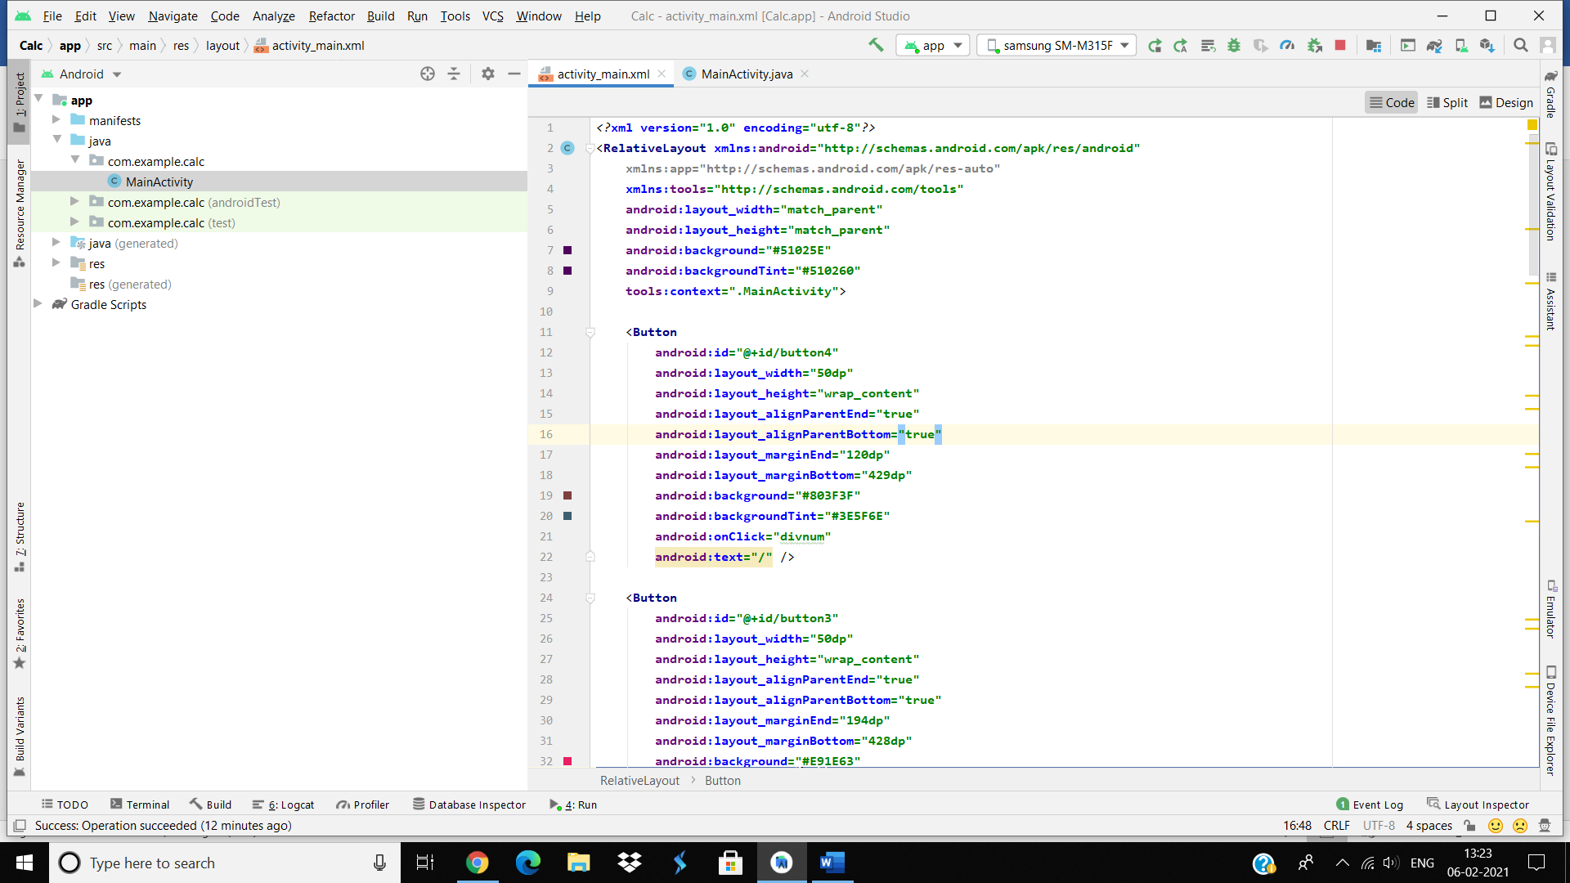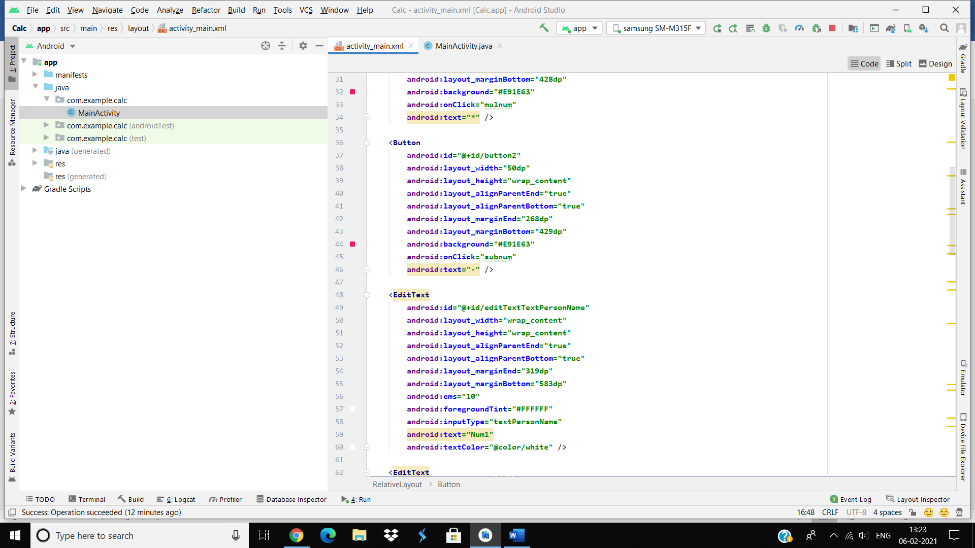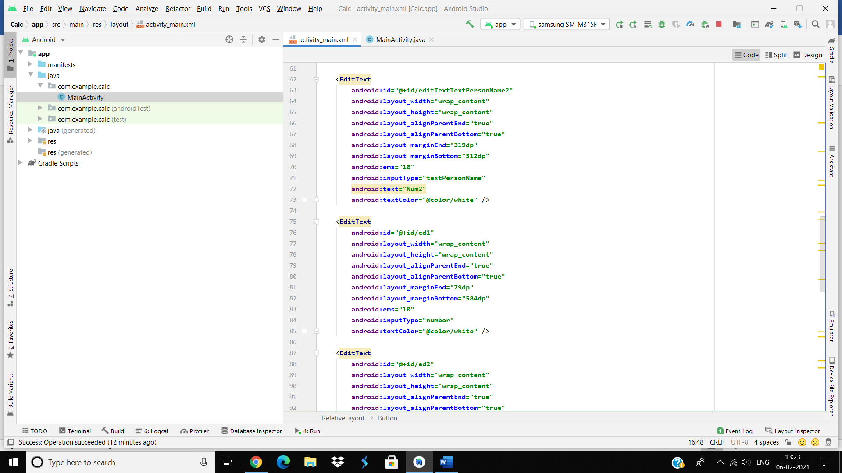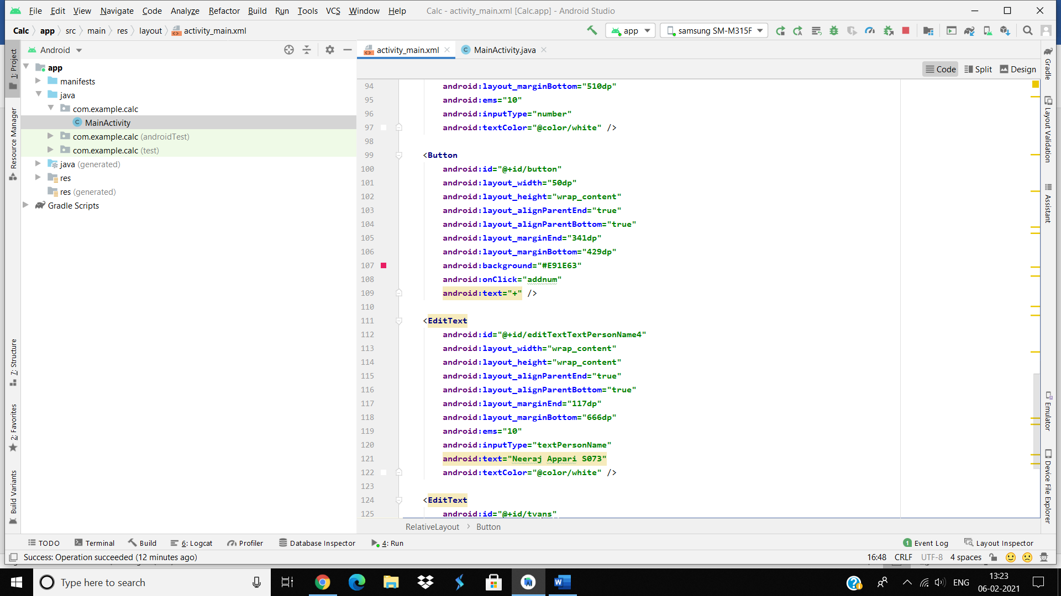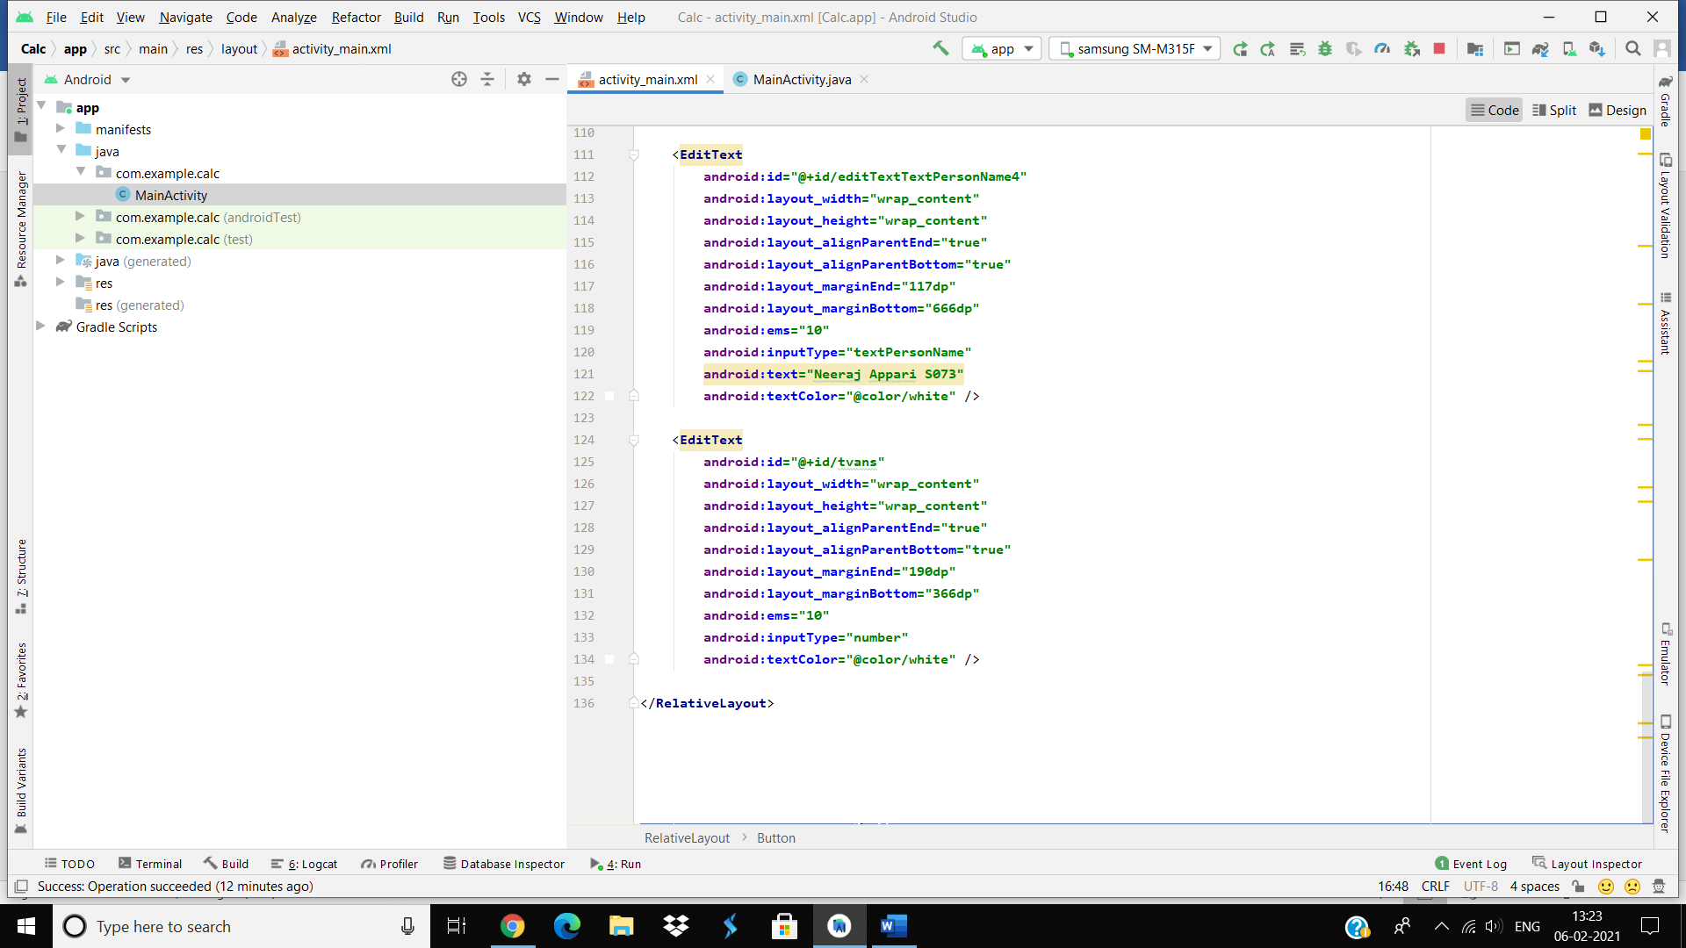

Java Code

package com.example.calc;

import androidx.appcompat.app.AppCompatActivity;

import android.os.Bundle;

import android.view.View;

import android.widget.EditText;

import android.widget.Toast;

public class MainActivity extends AppCompatActivity {

EditText e1,e2,t1;

@Override

protected void onCreate(Bundle savedInstanceState) {

super.onCreate(savedInstanceState);

setContentView(R.layout.activity_main);

e1 = findViewById(R.id.ed1);

e2 = findViewById(R.id.ed2);

t1 = findViewById(R.id.tvans);

}

public void addnum(View view)

{

int n1,n2,ans;

n1 = Integer.parseInt(e1.getText().toString());

n2 = Integer.parseInt(e2.getText().toString());

ans = n1 + n2;

t1.setText(ans+"");

Toast.makeText(getApplicationContext(),ans+"",Toast.LENGTH_LONG).show();

}

public void subnum(View view)

{

int n1,n2,ans;

n1 = Integer.parseInt(e1.getText().toString());

n2 = Integer.parseInt(e2.getText().toString());

ans = n1 - n2;

t1.setText(ans+"");

Toast.makeText(getApplicationContext(),ans+"",Toast.LENGTH_LONG).show();

}

public void mulnum(View view)

{

int n1,n2,ans;

n1 = Integer.parseInt(e1.getText().toString());

n2 = Integer.parseInt(e2.getText().toString());

ans = n1 * n2;

t1.setText(ans+"");

Toast.makeText(getApplicationContext(),ans+"",Toast.LENGTH_LONG).show();

}

public void divnum(View view)

{

int n1,n2,ans;

n1 = Integer.parseInt(e1.getText().toString());

n2 = Integer.parseInt(e2.getText().toString());

ans = n1 / n2;

t1.setText(ans+"");

Toast.makeText(getApplicationContext(),ans+"",Toast.LENGTH_LONG).show();

}

}

